Dear Parent/Guardian:

My name is Dawn Ryan and I am your child’s new language arts teacher at Academy 1! I have been a language arts teacher for the past seven years and a designated Highly Qualified Teacher in Language Arts by the Jersey City Board of Education for the past three years. I received my BA in British and American Literature from Brandeis University and my MFA in Creative Writing from Rutgers University. Literature is my life, and sharing literature with young people is a tremendous privilege that I take very seriously. My instruction style, you will come to learn, is different from your child’s previous instructors, but I assure you I deliver every lesson with your child’s needs in mind.

As I grow in my profession, I seek communication and feedback from all of the stakeholders in the Academy 1 community. With this purpose in mind, I have been collecting student work and documenting my lessons on my teacher website. My hope is to create greater transparency for students and parents and to continue to reflect on my practices. This letter along with your child’s homework and long term projects will be available on my website. As the year progresses, my website will serve as a record of your child’s achievements and successes in language arts.

In order for me to continue to learn and grow as an instructor, I ask that you and your child become active contributors to my site, providing me feedback and adding to the content. I will be recording select lessons throughout the year, and will be uploading these lessons onto my site. Although these video recordings involve both the teacher and various students, the primary focus is on my instruction, not on the students in the class. In the course of recording my teaching, your child may appear on the video or within images on my site. Also, I will collect samples of student work as evidence of my teaching practice, and that work may include some of your child’s work. No student’s name will appear on any materials that are submitted and materials will be kept confidential at all times. The form attached to this letter will be used to document your permission for these activities.

I appreciate all that you do for your child and I look forward to working with you over the course of this school year!

Sincerely,

Dawn Ryan

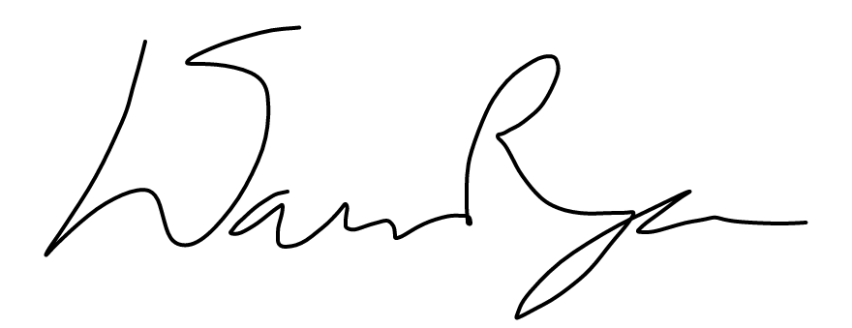

Student Release Form

PERMISSION SLIP

Student Name: __________________________________ I am the parent/legal guardian of the child named above. I have read and understand the project description given in the letter provided with this form, and agree to the following:

(Please check the appropriate box below.)

☐ I DO give permission to you to include my child’s student work and/or image on video recordings as part of video(s) showing your classroom performance to be used solely on Ms. Ryan’s website: goo.gl/WwdLek.

I understand that my child’s name and any other personally identifiable information about my child **will not** appear on any of the submitted materials.

☐ I DO NOT give permission to you to include my child’s student work and/or image on video recordings as part of video(s) showing your classroom performance to be used solely on Ms. Ryan’s website: goo.gl/WwdLek.

Signature of Parent or Guardian: ____________________________________ Date: ________________

Student Release Form

PERMISSION SLIP

Student Name: __________________________________ I am the parent/legal guardian of the child named above. I have read and understand the project description given in the letter provided with this form, and agree to the following:

(Please check the appropriate box below.)

☐ I DO give permission to you to include my child’s student work and/or image on video recordings as part of video(s) showing your classroom performance to be used solely on Ms. Ryan’s website: goo.gl/WwdLek.

I understand that my child’s name and any other personally identifiable information about my child **will not** appear on any of the submitted materials.

☐ I DO NOT give permission to you to include my child’s student work and/or image on video recordings as part of video(s) showing your classroom performance to be used solely on Ms. Ryan’s website: goo.gl/WwdLek.

Signature of Parent or Guardian: ____________________________________ Date: ________________